

**INSTRUCTOR EDITION**

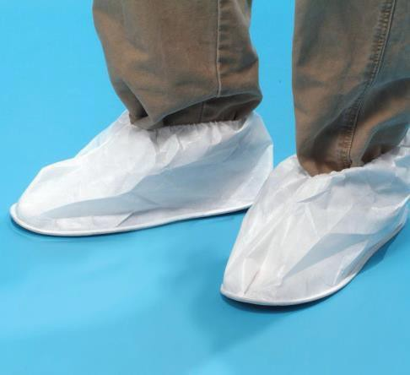 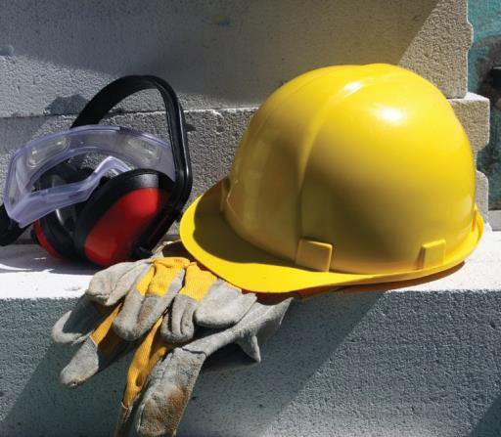 

**DO-IT-YOURSELF**

**PPE**

**TRAINING PROGRAM**

© Safety Services Company www.safetyservicescompany.com

***Information provided in this document may constitute legal information. Legal information is not the same as legal advice — the application of law to an individual's specific circumstances. We will do our best to provide you with neutral information that is accurate and useful, but we recommend you consult a lawyer if you want professional assurance that our information, and your interpretation of it, is appropriate to your particular situation. This document is not to be reproduced for commercial purposes. All of the contents within this document are the sole property of Safety Services Company.***

**TABLE OF CONTENTS**

Training Instructions 1

Introduction 3

General PPE 4

What is PPE? 4

Why PPE? 4

What PPE do I need? 4

PPE Types 5

Head Protection 5

Eye and Face Protection 6

Prevention 8

Hand Protection 9

Hearing Protection 11

Respiratory PPE 13

Air Purification devices 13

Respirator PPE use and maintenance 14

Foot Protection 16

Skin protection 17

Final Exam 18

# TRAINING INSTRUCTIONS

Before starting to train and certify your students, you should familiarize yourself with the content and structure of this program. This will make the training process easier to conduct. The purpose of this kit is twofold; it will help in the process of training your students, and it serves as a “train the trainer” document.

As an instructor you should be a “competent person” when it comes to Personal Protective Equipment, (PPE), and its use. Actual work experience with all types of PPE would be helpful. If you’re not already familiar with the different types of PPE, this program will take you through the steps.

Once you have reviewed the course you are now ready to start the training process for the employees. This process consists of three phases, they are:

* Classroom Training
* Hands on Instruction
* Evaluation

**Classroom Training:** The CD provided with this program contains interactive training software. This allows your students to take the training individually and at their own pace. This eliminates the need for you to conduct formal classroom training.

If you need to certify more than one employee, then you can use a projector, or large monitor to view the course. This way all of the trainees will be able to see the presentation in a classroom environment.

The CD also includes digital copies of the material in the training software and the quiz they will take. Feel free to print a training manual for each of the students so they may take notes and follow along.

If computer access on the job is limited or unavailable, you can use this booklet to lead your own training session. This documentation provides you with everything you need to deliver the classroom training. You don’t need to prepare any material yourself for this part of the training.

**Hands on Instruction:** After the students have finished their classroom training, it’s time to familiarize them with the different components of protective equipment. During this time, you’ll cover the PPE they’ll be expected to use while working. This is when they learn how to put on, inspect and maintain their PPE. Take your time in this phase, and be sure to give students an opportunity practice until they feel comfortable with their tasks.

**Evaluation:** Once you feel that the students are ready to start, you can begin the evaluation phase. Here is where you can ask them what the appropriate PPE would be for certain workplace conditions, test their knowledge of the equipment and have them demonstrate their ability to properly and safely use it. Your job will be to assess their performance and knowledge, and decide whether they are able to work safely using their PPE.

Now you’re ready to begin your training sessions. This booklet will serve as your lesson plan. With this, and the Student’s Handbook, you can bypass the computer training. This allows you to do the training on a job-site.



As you cover items of PPE, you can point out the key elements and reinforce the use and maintenance aspects. While you’re doing this, you should encourage the trainees to ask questions. The information contained here is the same as that in the student handbook and the training software.

**Refresher Training and Evaluation**

Refresher training, including an evaluation of the effectiveness of that training, must be conducted as required below to ensure that the operator has the knowledge and skills needed to use their PPE safely. Refresher training in relevant topics will be provided to the operator when:

* + The operator has been observed not using their PPE
  + The operator has been involved in an accident or near-miss incident
  + The operator has received an evaluation that reveals that they’re not using their PPE properly
  + The operator is assigned to a job that requires a different type of PPE
  + A condition on the job-site changes in a manner that could affect safe operation of the equipment

**Avoidance of Duplicative Training**

If an operator has previously received training in a topic covered in this program, and a competent person has determined that the training is adequate for the working conditions the operator will encounter, additional training isn’t needed.

**Certification**

The employer will certify that each operator has been trained and evaluated as required by this section. The certification will include the name of the operator, the date of the training, the date of the evaluation, and the identity of the person(s) performing the training or evaluation.

**NOTE:**

This training program focuses on the proper use of general Personal Protective Equipment. Because of the many different requirements and types available, it doesn’t address fall protection PPE. If you’re interested in in depth training on fall protection, there’s a separate training program for excavation available from Safety Services Company.

Contact us at 877-201-8923 or visit our website (safetyservicescompany.com) for information on this program.

# INTRODUCTION

Each year there are more than 4 million total workplace injuries.

This training program is designed to allow you to work safely by using the right Personal Protective Equipment or PPE.

The information in this program covers the following topics:

* General PPE information
* Personal protective equipment types
* Proper use of PPE
* Care and maintenance of PPE

Pay attention to the information for each of these topics, as there will be a comprehensive final exam at the end of the program.

You’re encouraged to attend other training classes to further your knowledge. This can include equipment specific training from the manufacturer as well as any additional training specific to you your work and jobsite.

And remember,

Safety should never be rushed.

# GENERAL PPE



**WHAT IS PPE?**

Personal protective Equipment, or PPE, is a collection of devices designed to keep you safe. They’re part of the toolset you use to do your job. PPE can protect your body, and possibly save your life.

**WHY PPE?**

In 2018, nearly 1 million workers were injured and missed days at work. Many of those injuries could have been avoided if protective equipment had been used or used properly.

* + 84% of workers who suffered head injuries weren’t wearing hardhats
  + 77% of those who injured their feet weren’t wearing safety shoes or boots
  + 60% of eye injuries occurred to workers not wearing eye protection
  + 70% of Hand injuries occurred to workers not wearing gloves

**WHAT PPE DO I NEED?**

Several governmental agencies define the standards for, and regulate the use of, Protective Personal Equipment. Only approved PPE should be used.

Employers are required to perform a hazard assessment of the jobs at their site and determine the hazards that exist and what PPE are needed.

Once they’ve done this, they must:

* + Provide you with the appropriate, approved equipment
  + Train you on how to wear and use the PPE
  + Maintain, repair, or replace any defective PPE

In return for the employer providing you with the equipment and training you’re required to:

* + Follow the instructions and directions you are given
  + Use the equipment properly
  + Keep your PPE clean and stored properly

This arrangement keeps you and jobsite safe, and helps get you home at night.

**Every day an average of 14 people go to work, and don’t come back.**

**Don’t be one of them.**

# PPE TYPES

Now that we know a little about the importance of PPE, let’s look at some of the types you may be using.

## HEAD PROTECTION

**Hardhats**

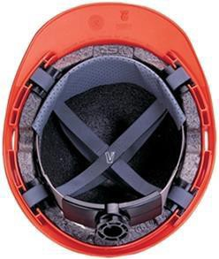The most common PPE for the head is the hardhat. Hardhats must be worn when you’re working in an area that’s been defined as hazardous. Depending on the type you have, your hardhat can protect you from:

* + - Falling objects
    - Electrical shock
    - Spills, splashes, or drips of chemicals or molten metals

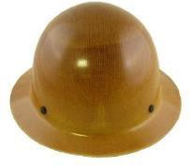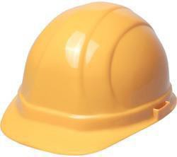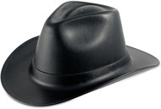Hardhats consist of a protective shell and a four-point suspension system. They come in a variety of types and colors and are made from different materials. What’s important is to know the protection they provide.

TYPE 1 TYPE 2 Western Style

Hardhat protection is divided into three classes, and defines the kind and level of protection they provide, they are:

* + - Class G – General (formally class A) Provides impact from the top protection and tested for electrical protection up to 2,200 volts
    - Class E – Electrical (formally class B) Provides top and side impact protection and tested for electrical protection to 20,000 volts
    - Class C – Conductive (remained class C) Provides impact protection only. These hats are often made of aluminum and are conductive. Don’t use a class C hardhat if working around electricity

Hardhats are also available with a variety of attachments such as eye and hearing protection, chinstraps and neck shades.

**Always use the hardhat type that’s right for your job.**

**Hardhat Care**



Make sure that your hard fits comfortably and securely. While there aren’t any regulations that define the life span of a hardhat, it must be replaced anytime it is found to cracked or damaged. Most manufacturers recommend replacing hardhats every five years.

To keep your hardhat providing the best protection it can follow these rules:

* + - * Don’t paint or scratch your hardhat
      * Don’t drill air holes in your hat
      * Don’t put metal tape or metal decals on your hat
      * Don’t store cigarettes, lighters, or pens in your hardhat
      * Clean the mild soap and water only
      * Store in a clean, dry, cool area

**Don’t leave your hardhat on the dashboard of your vehicle. Heat and sun will weaken your hardhat over time.**

**Bump Caps**

Bump caps are protective devices for your head that are designed for use in tight or low overhead clearance areas only. They don’t have suspension systems and aren’t intended to replace hardhats.

## EYE AND FACE PROTECTION

Eye and face protection is important when you’re working in areas where the following hazards exist:

* + Dust and particles such as sanding and grinding operations
  + Molten metal that could splash, spill, or splatter
  + Spills or splashes of chemicals
  + Areas where there’s intense light or laser work such as welding or cutting
  + Exposure to mist, vapors, or fumes from spraying
  + Risk of sparks or arcing from electrical work

**Eye Protection**

Eye protection comes in several different forms depending on the level you need. The choices range from basic safety glasses to welding helmets.

**Safety glasses**

Basic safety classes are intended to protect your eyes from impact hazards, flying chips or particles that would be created by grinding or sanding. All approved safety glasses should have the following features:

* + - 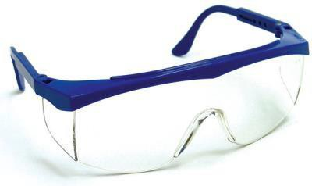Impact resistant lenses, either plain to prescription
    - Side shields, either permanent or attachable
    - Adjustable nose bridges and temples or head band

The lenses of safety glasses can be either permanent or removable and are usually available in different tints and filter grades depending on the level of protection required.

**Goggles**

Safety goggles provide a higher level of protection than glasses, and are used when working around liquids, molten metals and areas of high heat. Goggles can be rigid or flexible, ventilated, indirect ventilated, or non-ventilated, and are available with prescription, tinted, or filtering lenses.

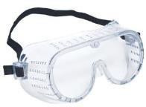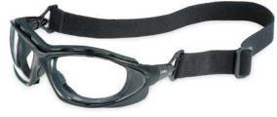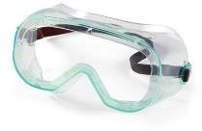

Ventilated Flexible Non-ventilated When wearing safety glasses or goggles keep these key points in mind:

* + - * Goggles should form a good seal with your face
      * Non-ventilated goggles are more likely to fog up
      * Keep your eye PPE clean and store in a cool dry place

**Face Protection**

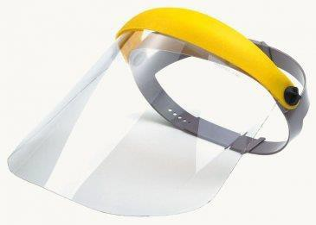Face shield are designed to protect your entire face, and should be used when working where heat, splashes of molten metal or chemicals, or sparks can occur. Face shields can be either a removable or a lift- front design and have adjustable headgear.

**Face shields are for skin protection and are not intended to replace safety glasses or goggles.**

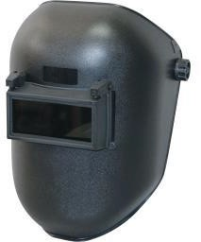**Protective helmets**



Protective helmets are most commonly used when welding and are intended to protect your face from sparks and metal splatter. Welding helmets usually have replaceable cover plates and a variety of filter shades for different types of work. Welding helmets like face shields, aren’t intended to replace safety glasses or goggles. Make sure you always have the level of eye protection you need.

**Lasers and glare**

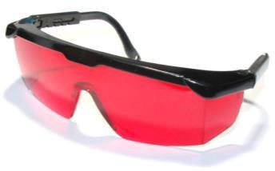Safety glasses or goggles with special filtering lenses are needed when using lasers or working where infrared, ultraviolet or high intensity light can be generated. The type and level of filtering required depends the exact type of hazard that exists. Ask your employers if you have any questions about the type of eye protection, you need.

## PREVENTION

If your job requires you to wear eye protection, whether you wear glasses or contacts or not, you should have you vision checked yearly.

If you wear contacts, you should know that some chemicals can react with them and this can result in an eye injury even if you’re wearing eye protection. Know the chemicals you work around.

**Eyewash stations**

Know where the eyewash stations are at your workplace and how to use them.

* + - Eyewash station should be located within 100 feet of your work area
    - Flush your eyes for 15 minutes
    - Hold your eyes open and look directly into the water stream
    - DO NOT RUB YOUR EYES

If you are working with chemicals, be aware that some of them can react with water. Know the chemicals you are working with and read the data sheets for them.

The risk of eye injuries can be further reduced with the use of:

* + - Work area barriers to protect other workers in the area
    - Ventilation to remove dust and airborne particles
    - Proper lighting to reduce eye strain and glare

## HAND PROTECTION

Hand injuries are the second most common work injury. Over a million workers a year are treated for hand injuries. These injuries can result in serious long-term problems. The most common types of injuries are:

* + Cuts
  + Bruises
  + Broken bones
  + Punctures
  + Burns
  + Sprains
  + Amputation (finger or hand)
  + Chemical absorption

The use of PPE can prevent many of these injuries. The primary PPE for preventing hand injuries is the use of the right glove.

**Gloves**

There are many types of work gloves available, make sure you have the ones suited to your job. Here’s a list of the more common types of safety gloves:

* + - Wire or metal mesh gloves provide good protection when working with material having sharp edges.
    - Leather gloves protect your hands from rough surfaces
    - Vinyl and neoprene gloves prevent injury from toxic chemicals
    - Rubber gloves insulate you when working around electricity
    - Cloth padded gloves protect your hands from cuts, slivers, dirt, and vibration
    - Use heat resistant gloves when working around flames and hot surfaces
    - Latex disposable gloves protect from germs and bacteria
    - 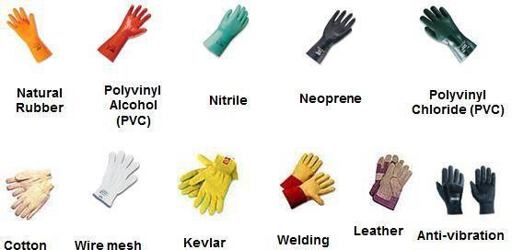Lead lined protect you from radiation sources

Regardless of the type of gloves you need for your job, the same rules apply:



* + - Make sure they’re the right type and size
    - Don’t wear watches or rings that could catch on, or tear gloves
    - Don’t wear gloves around powered rotating equipment such as drills or lathes
    - Inspect your gloves for tears, holes, or cracks before you use them

**Barrier creams**

Certain creams can be used to help protect your skin and hands from injury. They consist of:

* + - Water repellent creams – to protect your hands from caustic chemicals
    - Solvent repellent creams – Protects from solvents, oils, and organic chemicals
    - Sunscreens – provides protection from the sun
    - Vanishing creams – protects against mild acids and aids in clean-up

**You should never use a barrier cream instead of gloves.**

Other hand PPE devices are available if your work requires them.

* + - Forearm cuffs to protect from sparks, flying particles, or splashes
    - Thumb guards or finger cots protect your thumb or fingers from cuts
    - Mittens or hand pads can be used when handling hot or cold materials.

**Prevention**

In addition to the protective equipment for your eyes, face and hands we’ve discussed, there are other things to keep in mind:

* + - The machines you’re working with are equipped with safety guards. Always make sure they are in place and working properly
    - Always follow your company’s lockout and tag out procedures
    - Sloppy work areas can contribute to injuries
    - Wash your hands often to remove dirt and germs. This reduces the chance of infections and other skin problem such as dermatitis.

## HEARING PROTECTION

Studies show that the largest cause of hearing loss is work related injuries, and of that over 65% of that loss occurs in manufacturing and construction. Regardless of your occupation, hearing loss is permanent and can be difficult to detect because it’s gradual. You should have your hearing tested yearly. Work related hearing loss is usually due to prolonged exposure to high levels of noise. Here are some numbers about noise level, their risk levels and allowed exposures.

|  |  |
| --- | --- |
| Sound levels of common noises | |
| Decibels | Noise source |
| Safe range | |
| 30 | Whisper |
| 60 | Normal conversation |
| 70 | Washing machine |
| Risk range | |
| 85 to 90 | Heavy city traffic, power lawn mower, hair dryer |
| 95 | Motorcycle |
| 100 | Snowmobile, hand drill |
| 110 | Chain saw, rock concert |
| Injury range | |
| 120 | Ambulance siren |
| 140 (pain threshold) | Jet engine at takeoff |
| 165 | 12-gauge shotgun blast |
| 180 | Rocket launch |

|  |  |
| --- | --- |
| Maximum job-noise exposure  allowed by law **without PPE** | |
| Sound level, decibels | Duration, daily |
| 90 | 8 hours |
| 92 | 6 hours |
| 95 | 4 hours |
| 97 | 3 hours |
| 100 | 2 hours |
| 102 | 1.5 hours |
| 105 | 1 hour |
| 110 | 30 minutes |
| 115 | 15 minutes or less |

**Types of hearing loss**

There are two types of hearing loss, conductive and sensory.

* + - * Conductive hearing loss is due to injury to the outer or middle ear and can be caused by infection or eardrum perforation. This type of hearing loss reduces the level of sound you can hear
      * Sensory loss is often caused by noise on the job that results in damage to the inner ear. Sensory loss can also be caused by age. This type of injury will limit your ability to hear high-frequency sounds, understand speech, and seriously impair your ability to communicate.

The purpose of hearing PPE is to attenuate, or reduce, the noise level at your workplace. PPE won’t eliminate the noise, or the risk. In order to reduce or avoid hearing loss you should wear the PPE that’s appropriate for your job.

**Ear plugs**



Earplugs are available in two types, foam and rubber. The advantages of earplugs are that they’re lightweight and comfortable. The disadvantages are that they can be hard to fit, can come loose and get dirty easily.

**Foam plugs**

Foam earplugs can be considered either temporary or disposable. They are easier to use than rubber plugs and tend to provide a better level of protection. To install foam earplugs, you should remember the following:

* + - * Roll – Roll or twist the earplug between your thumb and forefinger to make the diameter smaller. Do this until the plug gets warm.
      * Pull – grab your ear from behind you head and pull back up to open the ear canal.
      * Hold – Insert the plug as far as possible into your ear and hold it in place for 10 seconds. This lets the plug expand and fill your ear canal.

Foam plugs should be replaced when they become dirty or torn.

**Rubber plugs**

Rubber or silicone earplugs are more durable than foam plugs. They can be cleaned with a mild soap and water and then reused but can also be harder to install and fit properly.

Rubber earplugs are installed much like foam ones except that the rolling step is not used. Instead when inserting the plug to your pulled back ear, use a circular motion to get a good seal in the ear canal. You will still need to hold the plug in place for 10 seconds. Replace your rubber or silicone plugs if they become torn or brittle.

**Always wear your earplugs. They’re cheaper than hearing aids.**

**Earmuffs**

Earmuffs can be used in place of earplugs for low to moderate noise levels. There are a number of things to consider when using earmuffs for hearing protection.

* + - * They’re easier to fit and use
      * Their use is easier to supervise because to their visibility
      * They last longer and one size fits all
      * They’re better for low frequency noise protection
      * They can be uncomfortable in the hot conditions
      * They can interfere with other PPE such as hardhats or face shields
      * Glasses, long or facial hair, can cause a bad seal and reduce their effectiveness

**Earplugs and earmuffs must be used together where the noise level exceeds 105 DBa**

**RESPIRATORY PPE**

There are four ways that hazardous material can enter the body:

* + Ingestion (eating)
  + Absorption (skin contact)
  + Inhalation (breathing)
  + Injection (breaking the skin)

Of these methods, inhaling is the most common.

Respiratory equipment is designed to protect your lungs when you’re working in an environment where contaminants are present. The type of PPE you’ll need depends on the type and level of hazards you’ll encounter. The contaminants that can enter your lungs fall into the following categories:

* + Dust from grinding or sanding operations
  + Vapors from the evaporation of thinners, gas, or solvents
  + Fog/mist from spraying work
  + Gasses escaping from containers, or created by processes
  + Fumes from the manufacture of plastic components or welding or soldering
  + Smoke from incomplete burning of material, usually during manufacturing any of these materials entering your lungs causes damage and can be cumulative.

**Types**

Breathing PPE devices are divided into two types and range from a dust mask to a fully self- contained breathing apparatus. The first category of breathing PPE, air purification, includes the devices most commonly used in the workplace; let’s look at some of these.

## AIR PURIFICATION DEVICES

**Dust mask**

Filtering face pieces, or dust masks, provide protection from dust, mists and fumes. They don’t protect you from gasses or vapors, and should never be used when working around asbestos or lead. Single strap dust masks aren’t considered approved PPE. Use a dual strap mask.

**Respirators**

Non-powered respirators are available in half and full-face models. Both use cartridges and/or filters to protect against vapors and acid gasses as well as dust and fumes. The filters and cartridges must match the type of contaminants at the workplace and must be changed regularly. Both of these respirators require a secure seal with the face and therefore present problems for workers with facial hair.

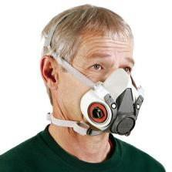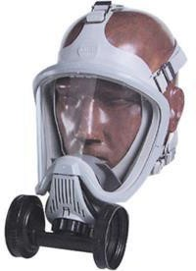

**Half face**

A half face respirator can be cooler when working in heat and lighter than a full shield.

**Full face**

Full face respirators provide the same level of protection as a half face, but they

add protection of the face and eyes.

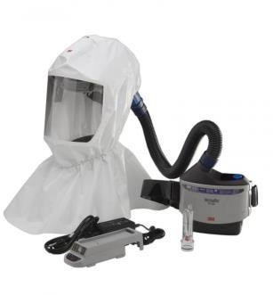**Powered air purifying respirator**

A powered air purify respirator, (PAPR), is a loose-fitting respirator that uses a battery powered fan to draw air through filters and move through a helmet or hood. These can be more comfortable to wear and can be used by workers who have beards.

**Supplied air respirators**

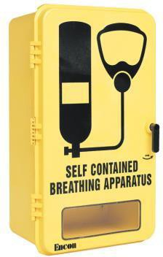Respirators that provide air from a source separate from the environment.

Supplied air respirators are used when air purifying respirators cannot provide sufficient protection from airborne particulate or chemicals.

Another type of supplied air respirator is the self-contained breathing apparatus or SCBA. These are generally intended for use in emergencies.

This is the same equipment used by divers, except that’s not underwater. In this case, the air is supplied from a tank, making it portable. These are sometimes called escape respirators. Another example of a supplied air respirator is the air mask on an airplane. In that case the air comes from a tank on the plane, and therefore isn’t mobile.

If you work in an area that has SCBA units available, make sure you know their location and how to use them.

## RESPIRATOR PPE USE AND MAINTENANCE

When determining the type of PPE you’ll use, there are some basic things to consider:

* + - What types of contaminants are present?
    - How dangerous are they?
    - How concentrated are they?
    - How long will you be exposed to them?

**Respirator Use**

Once the proper respirator has been determined, the next step to make sure it works and fits properly. Begin by putting on your respirator. To do this hold your respirator in one hand and place the straps over your head with the other, then tighten the straps from bottom to top.

**Always follow the manufacturer’s instructions when putting on your respirator.**

With your respirator properly in place, you’ll need to perform a seal test to make sure that the seal is good and everything is working properly. A seal test consists of two parts, a positive and a negative pressure test.

To perform a positive pressure test:

* + - Block the exhale valve of your respirator and breathe out
    - The mask should bulge out. Hold the pressure for 10 seconds
    - The mask should stay bulged out. If it does, you have a good seal.
    - If it doesn’t, there’s a leak. Readjust the respirator’s straps and repeat the test.

To perform a negative pressure test:

* + - Block the inhale valves with your hands and breathe in slowly
    - The mask should collapse slightly. Hold your breath for 10 seconds
    - If no air leaks in, you have a good seal.
    - If air does leak in, adjust the straps and repeat the test

**Maintenance**

There are some key steps to keeping your respirator working properly, the first is inspection.

* + - Inspect the face shield for cracks or chips
    - Check the straps and buckles for damage or wear
    - Make sure the fittings and valves are clean and seated properly. Inspect and seal test your respirator be every use.

Always be alert and monitor that your respirator is working properly. Watch for the following signs that there might be a problem:

* + - The filters or cartridges have expired
    - You can smell or taste contaminant
    - You have difficulty breathing
    - You feel dizzy or sick

Keep your respirator clean, and store it in a plastic bag to keep dust out. You should clean your respirator after every use. Make sure that it’s kept in a dry area away from extreme heat, cold and chemicals.

## FOOT PROTECTION



Taking care of your feet at work may not be at the top of your priority list, but an average of 50,000 people a year miss work due to foot injuries. The majority of these are caused by falling objects that weigh less than thirty pounds. Foot injuries can happen to anyone. Working safely and wearing the proper PPE can help you avoid foot and other injuries.

The most common foot related work injuries are:

* + Broken bones - from falling objects
  + Punctures - from nails or sharp objects
  + Crushing – from being run over
  + Burns – from chemicals or electricity
  + Slips – from wet or slippery surfaces

PPE for your feet consists of safety shoes or boots, and the type you should use depends on your work environment. Here are some common types and their purposes:

* + Steel toed – protect from falling objects and crushing
  + Steel toed with metatarsal guard – additional protective shield for the top of the foot
  + Reinforced sole – prevent puncture injuries
  + Rubber/latex – for wet or slippery surfaces
  + Nitrile – for use when working around oils, animal fats, or chemicals
  + Insulated – when working around electricity

Regardless of the type of foot PPE you use there are some basic rules to follow:

* + Make sure you have the right type of shoe or boot, and that they fit
  + Don’t wear cloth or leather shoes when working with chemicals
  + After working around chemicals wash off your shoes before removing them
  + Inspect your shoes for cracks or holes and replace if worn or torn
  + Don’t borrow anyone else’s shoes – They’re **Personal** protective equipment
  + Store your shoes in a clean, dry, ventilated place

In addition to using the right foot protection, you should always:

* + Follow good housekeeping practices to reduce the risk of slips, trips and falls.
  + Don’t put bulky or heavy objects where they could fall on someone’s feet
  + Stay clear of moving machinery, equipment, or vehicles
  + Keep your work area clean and free of trash and debris

## SKIN PROTECTION

Now that we’ve examined the PPE requirements for your head, eyes, ears, lungs, hands and feet, let’s take a minute to consider protecting the largest organ in your body – your skin. Your skin is subject to all of the hazards as the other parts of your body and needs protection as well.

Any part of your skin, whether exposed or not, is susceptible to cuts, puncture wounds, and burns. There are steps you can take, and items you can use to protect your skin from these injuries:

* + Barrier creams – can protect you from caustic chemicals and sun exposure, and can be used on other places besides your hands
  + Long sleeved shirts and long pants reduce the amount of skin exposed
  + Coveralls can provide additional protection, especially if they’re fire resistant
  + Smocks, lab coats, and chemical protective suits also provide additional protection of the body.

Make every effort to protect every part of your body. Always use all of your Personal Protective Equipment, all the time.

**PPE does no good if it’s not used!**

# FINAL EXAM



1. Who is responsible for performing a hazard assessment to decide the PPE that’s needed for your job?
   1. You
   2. Your supervisor
   3. The PPE Manufacturer

## Your employer

1. Your employer must provide you the necessary PPE for your job.
   1. **True**
   2. False
2. Which of the following is **not** considered PPE equipment?
   1. Hardhat
   2. **Belt**
   3. Dust mask
   4. Sunscreen
3. Approved eye protection is required to have side shield protection.
   1. **True**
   2. False
4. Which type of work doesn’t require the use of safety glasses or goggles with special filtering lenses?
   1. Welding
   2. Laser
   3. **Chemicals**
   4. Infrared
5. What type of gloves should be used when working with toxic chemicals?
   1. Leather
   2. Rubber
   3. Latex
   4. **Neoprene**
6. What type of gloves should be worn to protect you from radiation sources?
   1. **Lead lined**
   2. Steel mesh
   3. Vinyl
   4. Nitrile
7. What safety device is **not** considered PPE?
   1. Barrier cream
   2. Mittens
   3. **Machine guards**
   4. Face shield
8. What type of respirator is best suited for workers with facial hair?
   1. Dust mask
   2. Half face
   3. Full face
   4. **Powered air purifying**
9. When should you perform a seal test on your respirator?
   1. **Before each use**
   2. When you receive it
   3. After changing a filter or cartridge
   4. Monthly
10. What type of safety shoe or boot should you use when working around oils or chemicals?
    1. **Nitrile**
    2. Rubber
    3. Insulated
    4. Steel toed
11. Single strap dust masks are considered approved PPE. True

**False**

1. An emergency or escape respirator is also called a .
   1. PAPR
   2. SCUBA
   3. Full face
   4. **SCBA**
2. How long should earplugs be held in place after inserted?
   1. 2 seconds
   2. 5 seconds
   3. **10 seconds**
   4. 30 seconds
3. Respiratory PPE protects against all of these hazards except .
   1. Dust
   2. **RF**
   3. Vapors
   4. Smoke
4. Which of the following is **not** an eye hazard?
   1. Toxic gasses
   2. Mists
   3. **Reading lamp**
   4. Molten metals
5. When using an eyewash station you should:



* 1. Close your eyes and wash your face first
  2. Rub your eyes
  3. Drink plenty of water
  4. **Hold your eyes open and look into the water stream**

1. A respirator seal test consists of:
   1. A positive pressure test
   2. A negative pressure test
   3. **Both a positive and a negative pressure test**
2. At what sound level is hearing protection required?
   1. 75 DBa
   2. **90 DBa**
   3. 100 DBa
   4. 105 DBa
3. Which is **not** a method that contaminants can enter your body?
   1. **Osmosis**
   2. Absorption
   3. Ingestion
   4. Inhalation
4. What type of gloves should be worn when working with a drill press?
   1. Steel mesh
   2. Cotton
   3. Lead lined
   4. **None**
5. Which is **not** your responsibility as an employee?
   1. Learning about your PPE
   2. **Keeping records of the workplace assessment and your training**
   3. Following all warnings and precautions
   4. Reporting unsafe conditions to your supervisor
6. Which of the following is **not** used in determining the type of respirator to need?
   1. The type of hazard
   2. The level of the hazard
   3. The amount of time you’ll be exposed to the hazard
   4. **The level of you hearing**
7. A Class C hardhat will protect you from electrical shocks up to 20,000volts.
   1. True
   2. **False**
8. What are the two type of hearing loss?
   1. Physical and mental
   2. **Conductive and sensory**
   3. Loud and soft
   4. Rapid and gradual
9. Which is **not** a type of hazard for your feet?
   1. Broken bones
   2. Crushing
   3. Burns
   4. **Dermatitis**
10. At what sound level is the use of earplugs and earmuffs required together?
    1. 70 DBa
    2. 90 DBa
    3. **105 DBa**
    4. 120 DBa
11. If your eye protection becomes oily or dirty, clean it using an abrasive soap. True

**False**

1. You can always substitute barrier creams for wearing gloves. True

**False**

1. Which of these should you **not** do when using safety footwear?
   1. Select the right kind for your job
   2. Select a footwear that fits
   3. **Wear cloth footwear when working with acids**
   4. Store your footwear in a clean, cool, dry, ventilated area